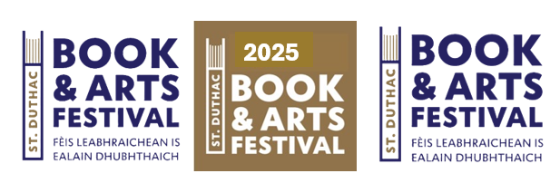

Academy School Art Competition
Terms and Conditions
Students from Tain Royal Academy and St Duthus School, from S1 to S6, are invited to submit a piece of their art, in any medium, into the Schools’ Art Competition. All entries will be displayed, and the public will be invited to vote for their favourite.
Artist Brief
Finished artwork will be collected from the Art Department of each school on Friday 5th September. The work will be put on display in the pop-up bookshop located in the Masonic Lodge,Tain, for the duration of the festival. No late submissions will be accepted.
Competition
There will be a 1st prize (£50), 2nd prize (£30) and 3rd prize (£20) awarded to the entrants with the most public vote. In the event of a draw the St Duthac Book and Arts Festival Chairperson will have the casting vote.
Terms and conditions:
- The competition is open to TRA and St Duthus School S1 to S6 students.
- To enter, you need to complete the attached registration form.
- Entrants will receive an entry number, which will be attached to their finished artwork. We would prefer that you do not sign your work prior to display. If you do sign your artwork, please be aware that your name will be covered to keep all submissions anonymous to the public.
- Entrants must provide their own art material, paper, canvas etc.
- Students may choose whichever medium they prefer, bearing in mind the space available for display, and within reason. We need to limit the maximum size of any artwork to approximately 1 metre in any one direction, including any frame.
- Other works of art (e.g., sculpture) need to be of a similar size or smaller. If unsure, please speak to a member of the St Duthac Book and Arts Committee who will have final say.
- Please submit your artwork in the form you wish it to be displayed (framed/mounted/unmounted etc.)

- Please note that the St Duthac Book and Art Group cannot be held responsible for damage or loss of artwork whilst displayed.
- Each participant may only enter one piece into the competition.
- Please note the competition will only go ahead if there are 10 or more entrants.
Competition – voting
- Members of the public, including students who have entered the competition, will be invited to come along to view and vote for their favourite artwork, during the festival from the 9th to the 13th September 2025.
- Official voting slips will be available on entry. Only one voting form will be allowed per person and proxy votes are not allowed.
- The winners will be invited to a presentation.
- The winners will be announced at the presentation on Sunday 14thSeptember, in the Collegiate Church, Tain, from 2pm.
- Artworks will be returned to the Art Departments of both schools the week beginning Monday 15th September.

If you wish to take part in the competition, please read our terms and conditions before completing the entry form below. Thank you.
Schools’ Art Competition Entry Form
In signing this document, you are understood to give your consent to your personal data being held by the St Duthac Book and Arts Event. Your data will only be used for the purposes of the competition.
We also assume that by entering your artwork into the competition you, as artist and originator of the work, understand and agree that you are granting us (the St Duthac Book and Arts Festival Group) a royalty-free, non-exclusive licence to publish and use the image of artwork on any of our materials, social media, or our website.

First Name: |  | Surname:
e.mail contact: |  | Telephone:
School: |  | Year:
I have read and understood the terms and conditions, and I accept that the St Duthac Book & Art Group cannot be held responsible for any loss or damage of my artwork whilst in their care.
Artist Signature……………………………………... Date……………………….

____________________________________________________________________________________
Official Use:
Entry Number: | Vote Count:
Completed by:

